SIMATS ENGINEERING
ASSESSMENT TOOL 1

COURSE CODE: MLA03
COURSE NAME: Reinforcement learning for Environment and Agent

COURSE OUTCOME COVERED

CO3: Implement policy-based reinforcement learning methods to develop efficient solutions for complex environments. (BL2, BL3, BL6)

Assessment Tool Weightage: 30%

Dr G. A. SENTHIL

QUESTIONS: 10 Total Marks: 50

Annexure A

CODING CHALLENGE Duration: 2hrs

1.Predict the Reinforcement Learning (RL) framework by describing the agent–environment interaction, emphasizing the importance of states, actions, and rewards, and discuss how cumulative reward influences decision-making. (5 marks)
Problem Statement
Design a Reinforcement Learning framework to demonstrate agent–environment interaction using states, actions, rewards, and cumulative rewards for decision-making.
Objectives
- Understand the RL framework.
- Simulate agent–environment interaction.
- Calculate cumulative rewards.
Eligibility
- Basic knowledge of Python.
- Understanding of Reinforcement Learning concepts.
Challenge Rules
- Define states, actions, and rewards.
- Simulate agent movement.
- Calculate cumulative reward.

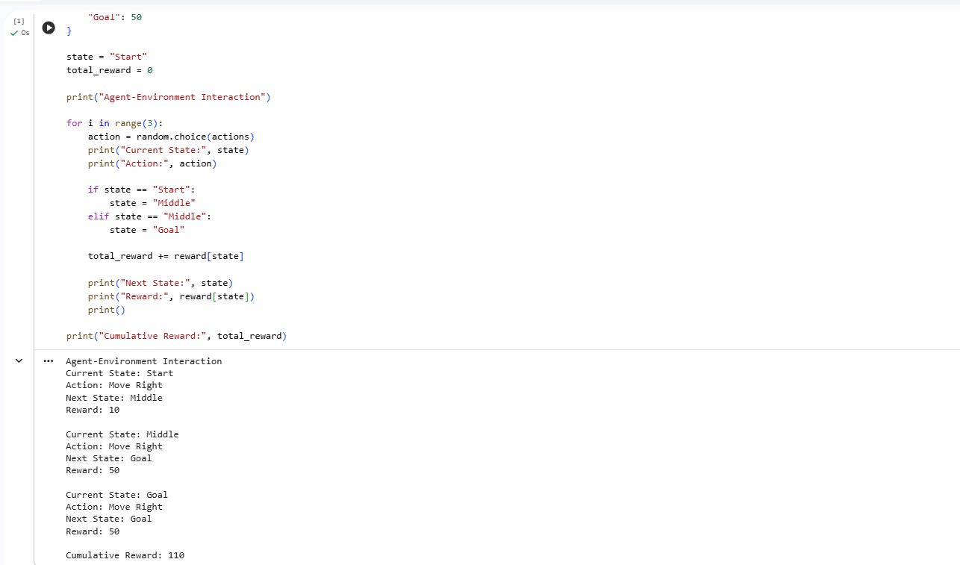
2. Estimate how decision-making problems can be modeled as a Markov Decision Process (MDP), detailing the components of action space, transition probability, reward function, and discount factor. (5 marks)
Problem Statement
Implement a Markov Decision Process (MDP) by defining states, actions, transition probabilities, rewards, and discount factor.
Objectives
- Model decision-making using MDP.
- Implement transition probabilities.
- Compute rewards.
Eligibility
- Knowledge of MDP.
- Basic Python programming.
Challenge Rules
- Define state space.
- Define action space.
- Use a discount factor.

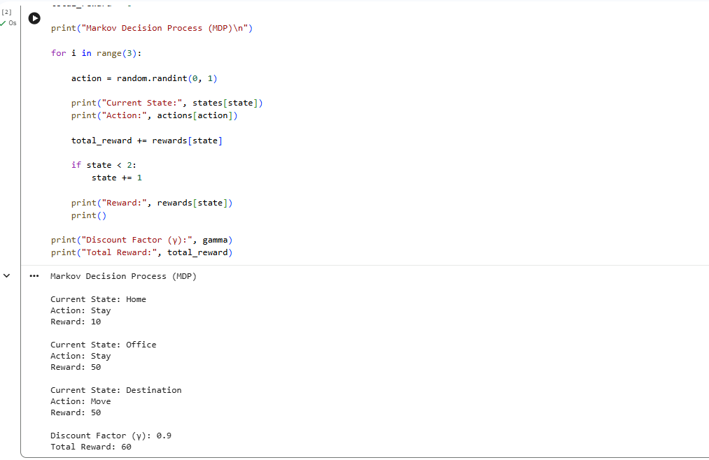
3. Discuss the role of policy and value functions in RL, and examine how state-value and action-value functions contribute to evaluating long-term benefits of actions using the Bellman Equation. (5 marks)
Problem Statement
Implement policy and value functions using the Bellman Equation to estimate long-term rewards.
Objectives
- Compute state values.
- Apply the Bellman Equation.
- Determine the optimal policy.
Eligibility
- Knowledge of Bellman Equation.
- Basic Python.
Challenge Rules
- Compute state values.
- Display optimal policy.

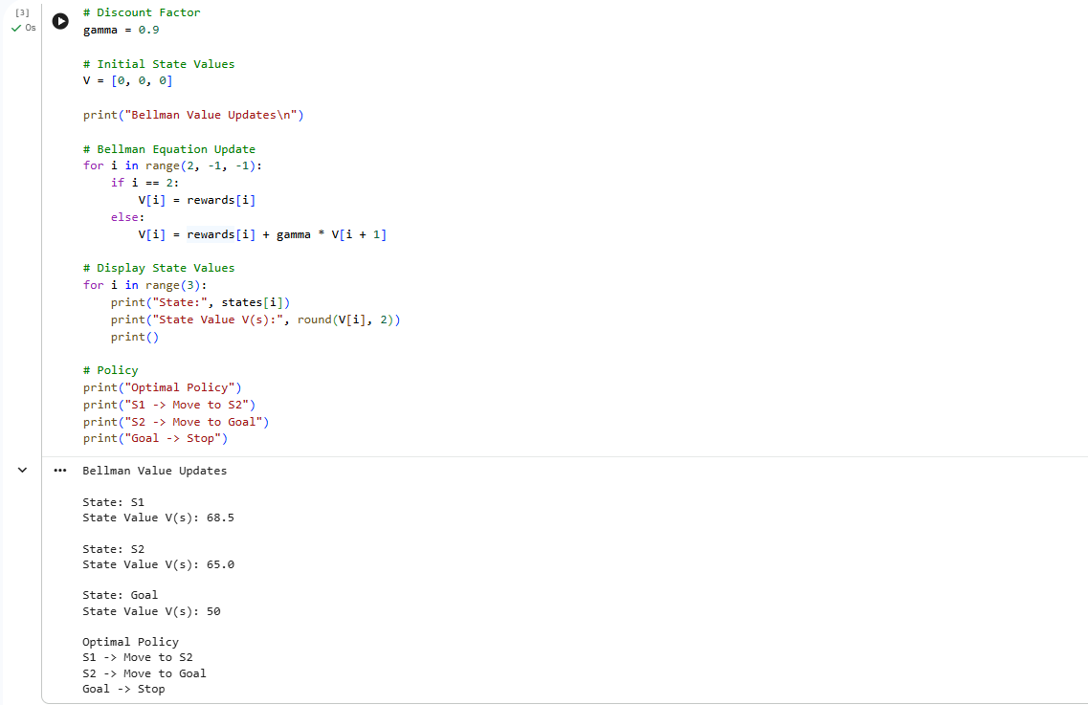

4. Justify the exploration–exploitation trade-off in RL and compare strategies such as ε-greedy and softmax approaches in balancing learning efficiency. (5 marks)
Problem Statement
Implement ε-greedy and Softmax strategies to balance exploration and exploitation.
Objectives
- Compare ε-greedy and Softmax.
- Select optimal actions.
Eligibility
- RL basics.
- Python.
Challenge Rules
- Implement both strategies.
- Display selected actions.
Programming Language
Python 3

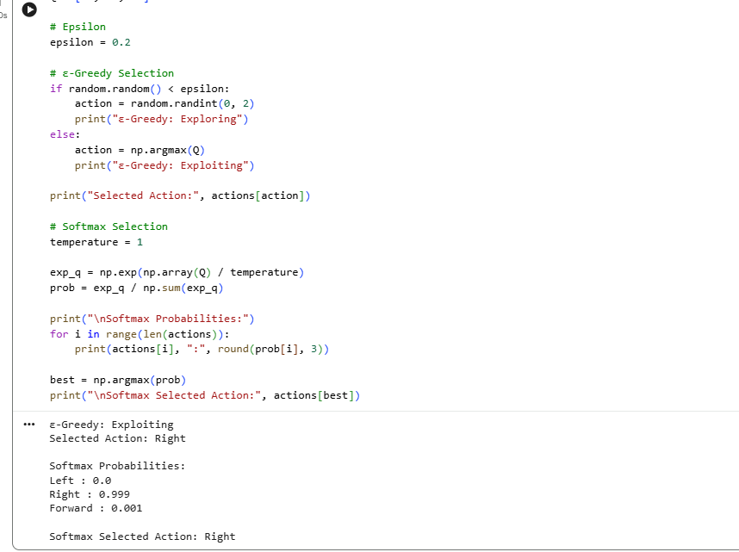
5. Explain how reward shaping can accelerate learning in RL and illustrate its impact on preventing suboptimal policies. (5 marks)
Problem Statement
Implement reward shaping to accelerate Reinforcement Learning and prevent suboptimal policies.
Objectives
- Improve learning speed.
- Compute cumulative rewards.
Eligibility
- Basic RL concepts.
Challenge Rules
- Use intermediate rewards.
- Calculate total reward.

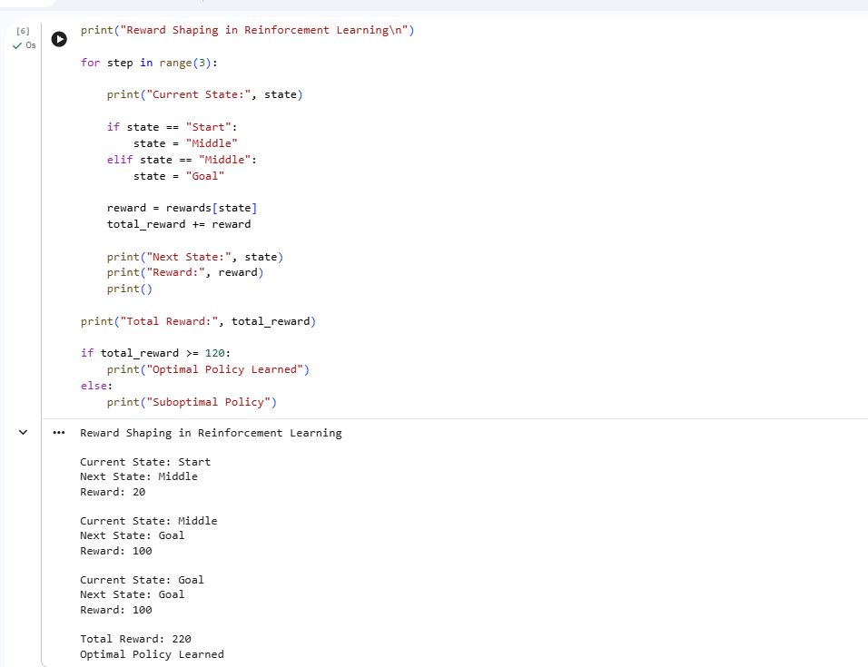
6. Identify the challenges of applying RL in real-world robotics and analyze how safety, sample efficiency, and environment variability affect agent performance.
(5 marks)
Problem Statement
Develop an RL model for robot navigation considering safety and environment variability.
Objectives
- Implement robot navigation.
- Avoid obstacles.
Eligibility
- Python.
- RL basics.
Challenge Rules
- Learn optimal actions.
- Update Q-table.

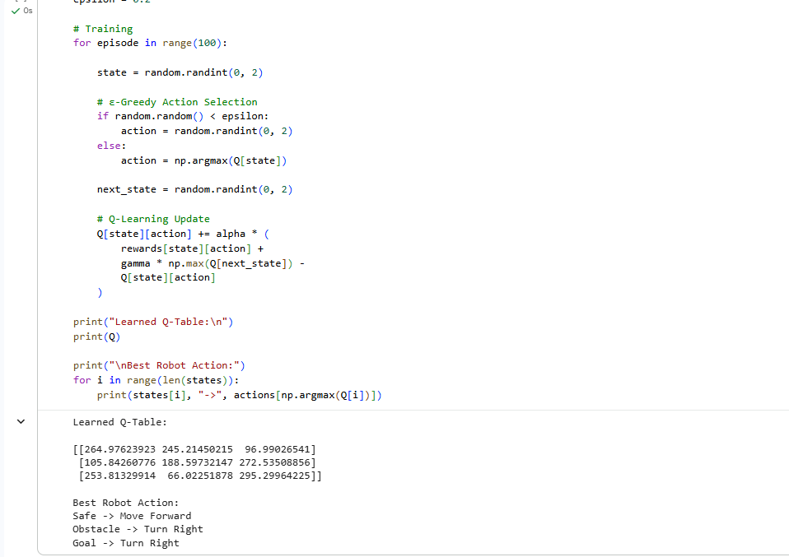
7. Analyze the influence of the discount factor (γ) on short-term versus long-term decision-making, and evaluate its role in episodic tasks. (5 marks)
Problem Statement
Implement the discount factor (γ) to compare short-term and long-term decision-making.
Objectives
- Compute discounted rewards.
- Compare decisions.
Eligibility
- Bellman Equation.
- Python.
Challenge Rules
- Compute state values.
- Display decision.
Programming Language
Python 3

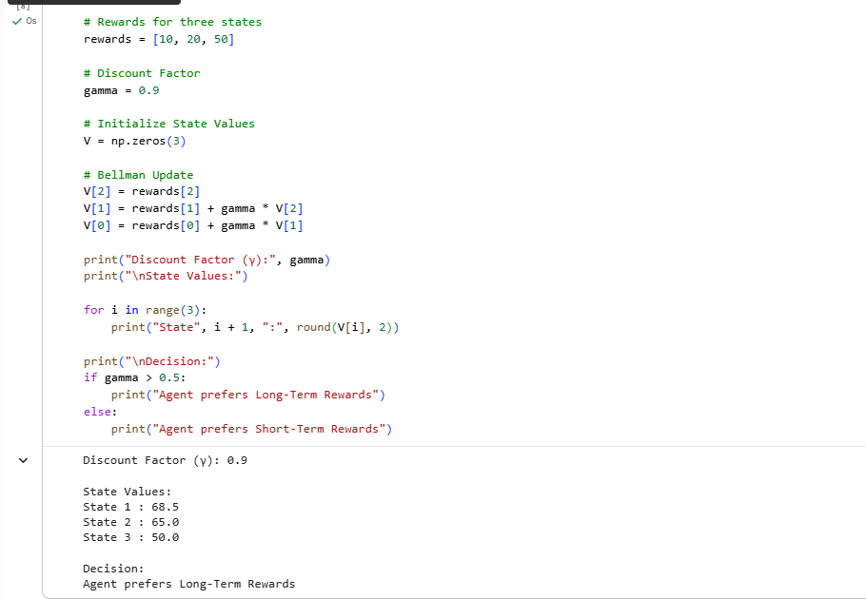
8. Evaluate the effectiveness of model-free RL compared to model-based RL in dynamic environments, and differentiate their strengths and limitations. (5 marks)
Problem Statement
Compare Model-Free and Model-Based Reinforcement Learning methods.
Objectives
- Compare learning methods.
- Compute value estimates.
Eligibility
- RL basics.
- Python.
Challenge Rules
- Display both approaches.
Programming Language
Python 3

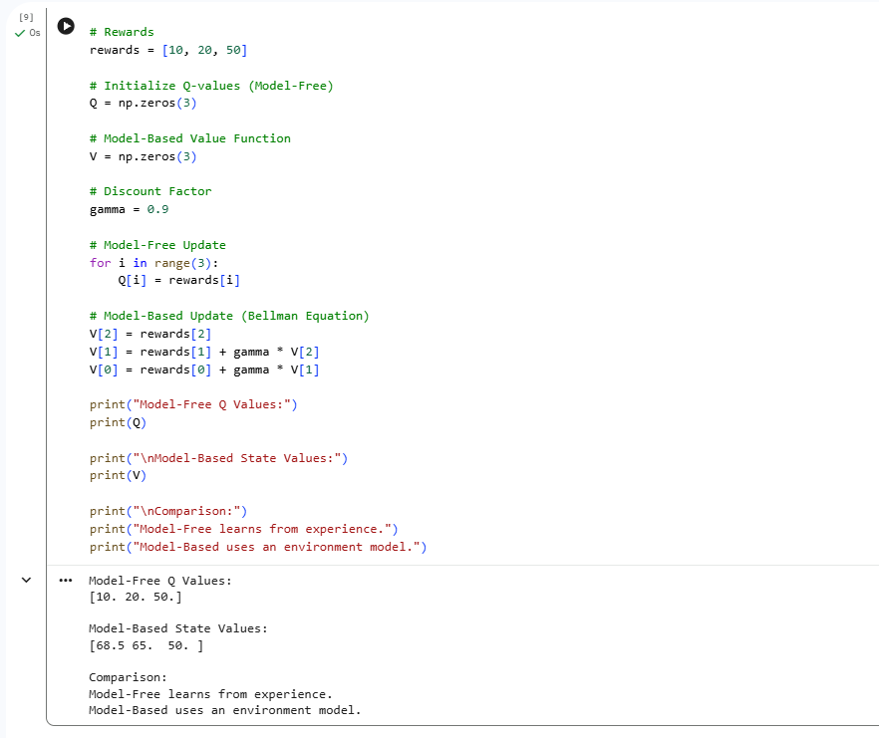
9. Illustrate with an example how Q-learning updates the action-value function during training, and demonstrate its convergence behavior. (5 marks)
Problem Statement
Implement Q-Learning and demonstrate Q-value updates during training.
Objectives
- Learn optimal policy.
- Update Q-values.
Eligibility
- Q-Learning knowledge.
- Python.
Challenge Rules
- Update Q-table.
- Display optimal policy.
Programming Language
Python 3

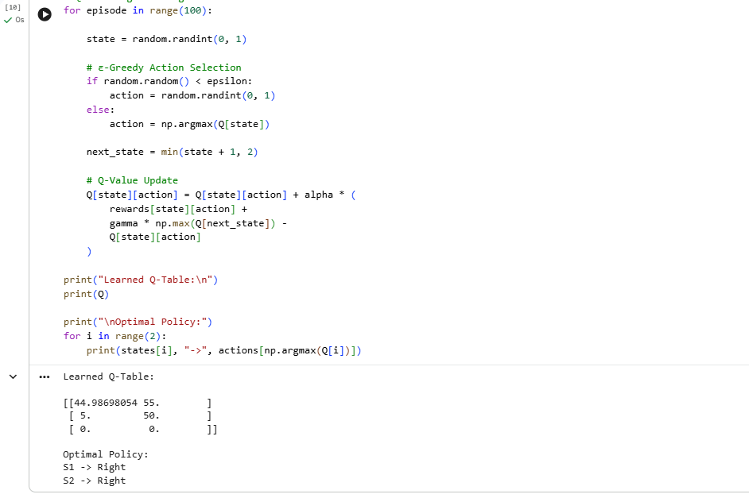
10 Differentiate between on-policy and off-policy learning methods in RL, and assess their advantages and limitations in practical applications. (5 marks)
Problem Statement
Compare On-Policy (SARSA) and Off-Policy (Q-Learning) methods.
Objectives
- Implement both algorithms.
- Compare Q-value updates.
Eligibility
- SARSA.
- Q-Learning.
- Python.
Challenge Rules
- Update both Q-tables.
- Compare outputs.
Programming Language
Python 3

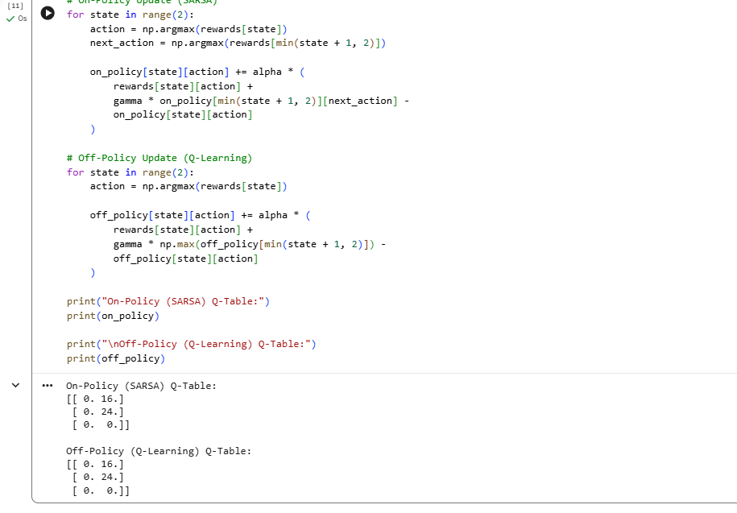

Code of Conduct:

I ________M.Samanvi (192425318)____________ (Name / Reg No) certify that this submission is my original work and that I have adhered to the guidelines specified for this assessment.
I understand that any violation of academic integrity rules will result in disciplinary action.

Signature of the student: M.Samanvi

RUBRICS FOR CALCULATION

Criteria | Weightage | Level 4 (Exemplary) | Level 3 (Proficient) | Level 2 (Developing) | Level 1 (Beginning)
Technical Knowledge | 25 | Demonstrates strong and accurate subject knowledge with in-depth understanding | Shows good knowledge with minor gaps | Basic knowledge with noticeable errors | Lacks fundamental technical knowledge
Problem Solving | 25 | Solves problems logically and applies concepts effectively in real scenarios | Applies concepts with moderate accuracy | Limited problem-solving ability; requires guidance | Unable to solve or apply concepts
Analytical Thinking | 15 | Analyzes questions critically and provides well-structured, logical answers | Provides reasonable analysis with some structure | Superficial or partially structured responses | No analytical thinking demonstrated
Communication | 15 | Communicates clearly, confidently, and professionally with proper terminology | Communicates well with minor hesitation | Communication lacks clarity or confidence | Unable to communicate effectively
Confidence | 15 | Displays high confidence, positive attitude, and professional behavior throughout | Shows good confidence with minor issues | Low confidence; inconsistent behavior | Lacks confidence and professionalism
Response to Questions | 10 | Responds accurately, promptly, and elaborates with relevant examples | Responds correctly but with limited depth | Partial responses; needs prompting | Unable to respond appropriately

